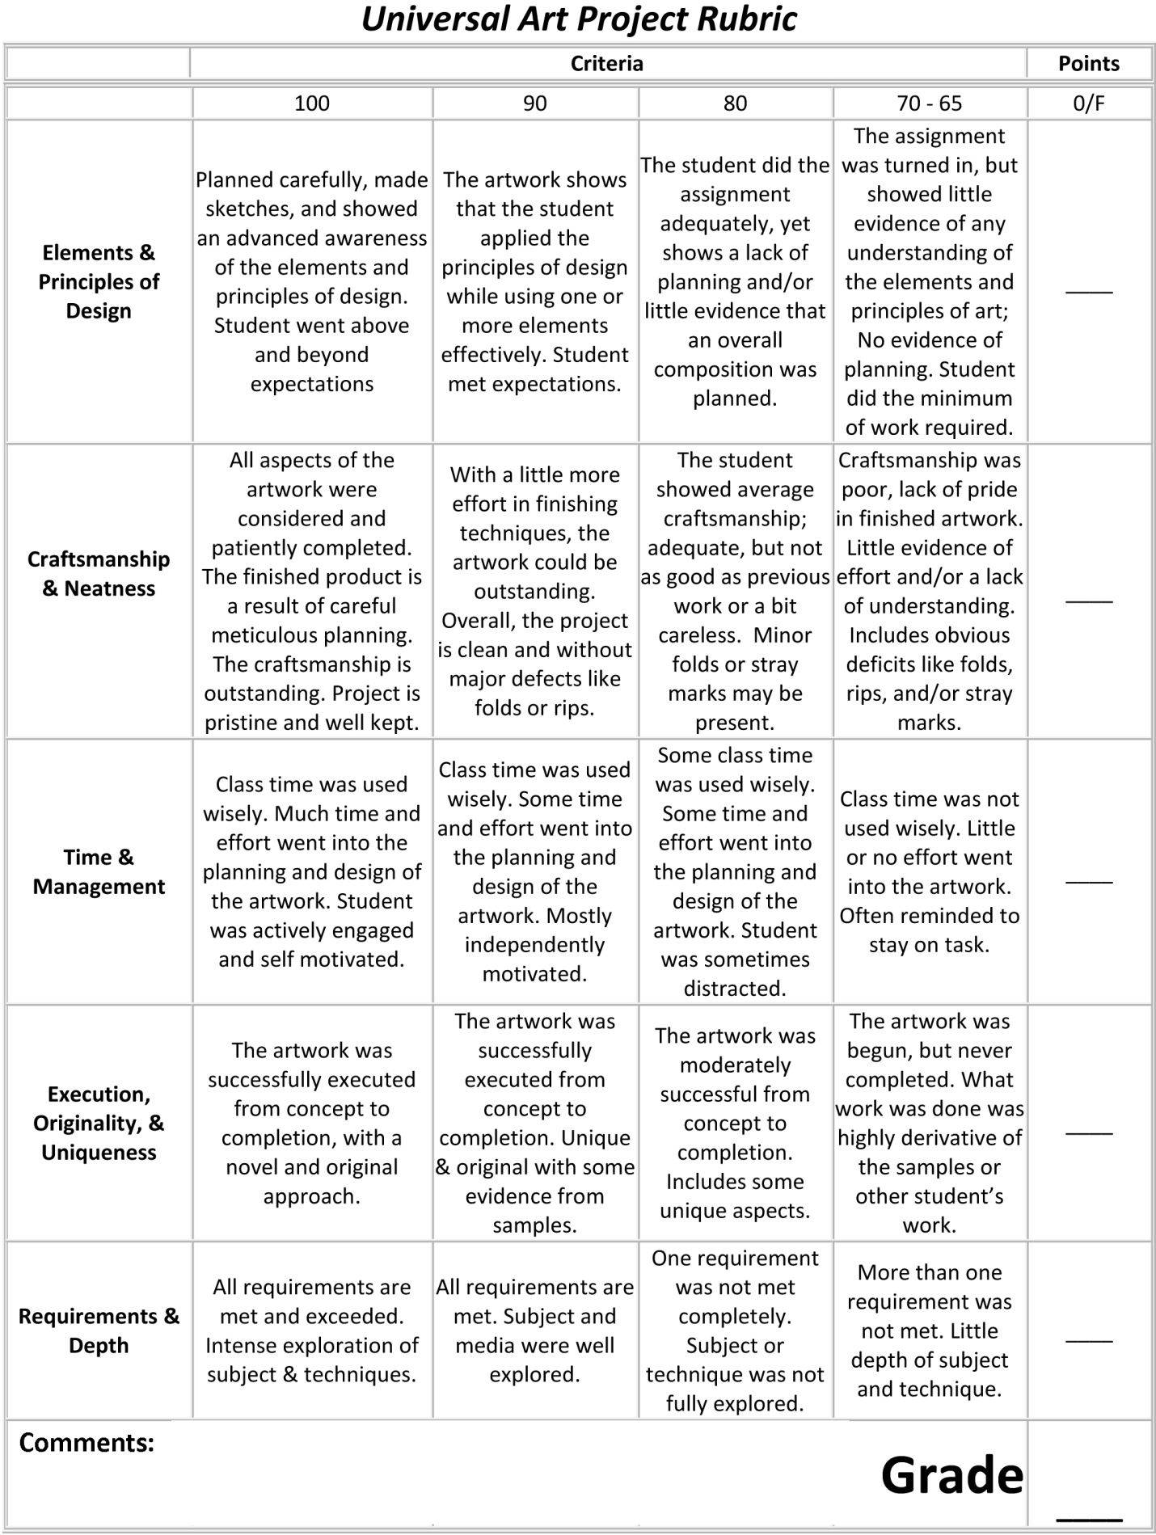

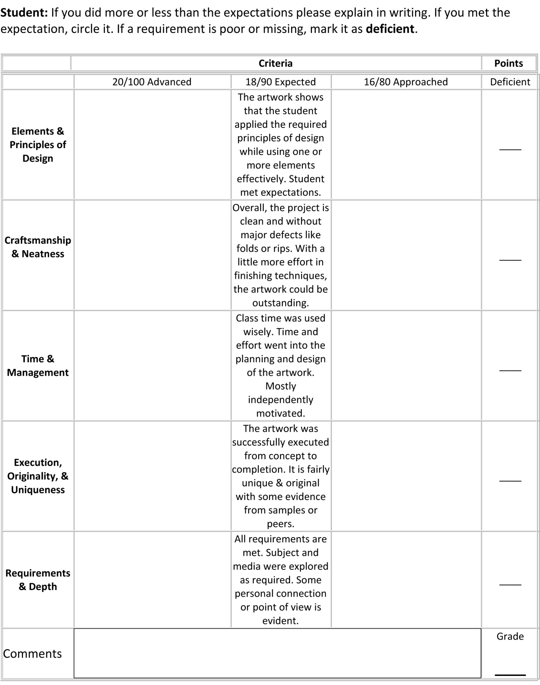

Assessment: Graded by both the teacher and the student. Only the teacher’s grade counts, but if there is a difference between the assessments, this can be discussed.

Project Title _________________________________________ Date Complete ___________________

Short Description: _____________________________________________________________________
Assess a grade of “A, B, C, D or F.” You may add + or – if you feel the need.
Student Assessment Below Teacher Assessment Below.
Neatness _____ Neatness _____
Completeness _____ Completeness _____
Originality _____ Originality _____
Following Directions _____ Following Directions _____ ________
Meeting Project Goals _____ Meeting Project Goals _____ Recorded Grade

--------------------------------------------------------------------------------------------

Project Title _________________________________________ Date Complete ___________________

Short Description: _____________________________________________________________________
Assess a grade of “A, B, C, D or F.” You may add + or – if you feel the need.
Student Assessment Below Teacher Assessment Below.
Neatness _____ Neatness _____
Completeness _____ Completeness _____
Originality _____ Originality _____
Following Directions _____ Following Directions _____ ________
Meeting Project Goals _____ Meeting Project Goals _____ Recorded Grade

--------------------------------------------------------------------------------------------

Project Title _________________________________________ Date Complete ___________________

Short Description: _____________________________________________________________________
Assess a grade of “A, B, C, D or F.” You may add + or – if you feel the need.
Student Assessment Below Teacher Assessment Below.
Neatness _____ Neatness _____
Completeness _____ Completeness _____
Originality _____ Originality _____
Following Directions _____ Following Directions _____ ________
Meeting Project Goals _____ Meeting Project Goals _____ Recorded Grade

--------------------------------------------------------------------------------------------

Project Title _________________________________________ Date Complete ___________________

Short Description: _____________________________________________________________________
Assess a grade of “A, B, C, D or F.” You may add + or – if you feel the need.
Student Assessment Below Teacher Assessment Below.
Neatness _____ Neatness _____
Completeness _____ Completeness _____
Originality _____ Originality _____
Following Directions _____ Following Directions _____ ________
Meeting Project Goals _____ Meeting Project Goals _____ Recorded Grade
